PROBLEM SOLVING AND TESTING USING JAVA

Course code:10211CS227

NAME:V.NEELA DEVI

VTU NO: 28598

WEEK 6 PROBLEMS

SESSION 1
Task1:https://www.hackerrank.com/challenges/string-similarity
import java.io.*;
import java.util.*;

public class Main {

static long stringSimilarity(String s) {
int n = s.length();
int[] z = new int[n];

int left = 0, right = 0;

// Z-Algorithm
for (int i = 1; i < n; i++) {

if (i <= right) {
z[i] = Math.min(right - i + 1, z[i - left]);
}

while (i + z[i] < n &&
s.charAt(z[i]) == s.charAt(i + z[i])) {
z[i]++;
}

if (i + z[i] - 1 > right) {
left = i;
right = i + z[i] - 1;
}
}

// Similarity with the string itself
long sum = n;

// Similarity with every suffix
for (int i = 1; i < n; i++) {
sum += z[i];
}

return sum;
}

public static void main(String[] args) throws Exception {

BufferedReader br = new BufferedReader(new InputStreamReader(System.in));

int t = Integer.parseInt(br.readLine().trim());

StringBuilder output = new StringBuilder();

while (t-- > 0) {
String s = br.readLine().trim();

output.append(stringSimilarity(s)).append('\n');
}

System.out.print(output);
}
}
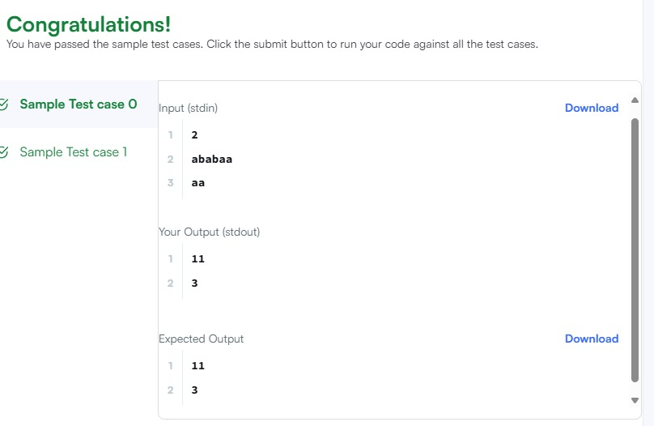
Task 2:https://leetcode.com/problems/repeated-substring-pattern/
class Solution {
public boolean repeatedSubstringPattern(String s) {
String doubled = s + s;

// Remove the first and last character
String sub = doubled.substring(1, doubled.length() - 1);

return sub.contains(s);
}
}
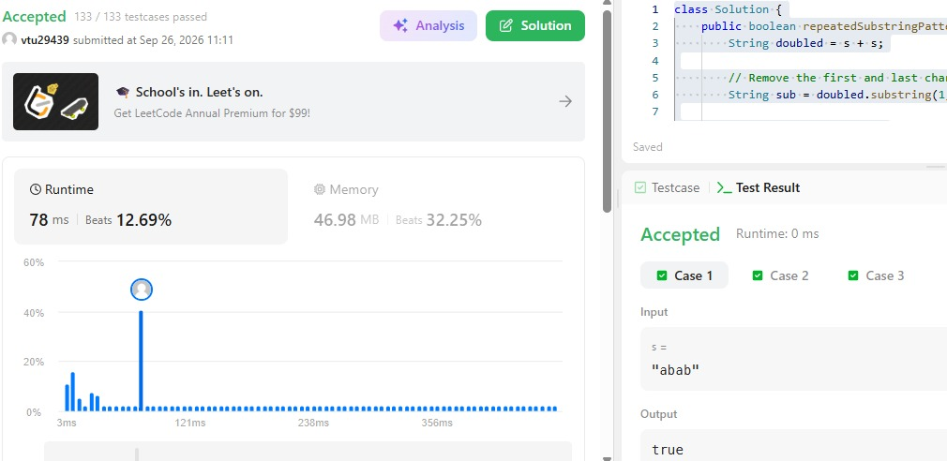
SESSION 2
Task3:https://www.hackerrank.com/challenges/two-strings/
import java.io.*;
import java.util.*;

public class Solution {

static String twoStrings(String s1, String s2) {
boolean[] seen = new boolean[26];

// Mark characters present in s1
for (char c : s1.toCharArray()) {
seen[c - 'a'] = true;
}

// Check whether any character of s2 is present in s1
for (char c : s2.toCharArray()) {
if (seen[c - 'a']) {
return "YES";
}
}

return "NO";
}

public static void main(String[] args) {
Scanner sc = new Scanner(System.in);

int q = sc.nextInt();

while (q-- > 0) {
String s1 = sc.next();
String s2 = sc.next();

System.out.println(twoStrings(s1, s2));
}

sc.close();
}
}
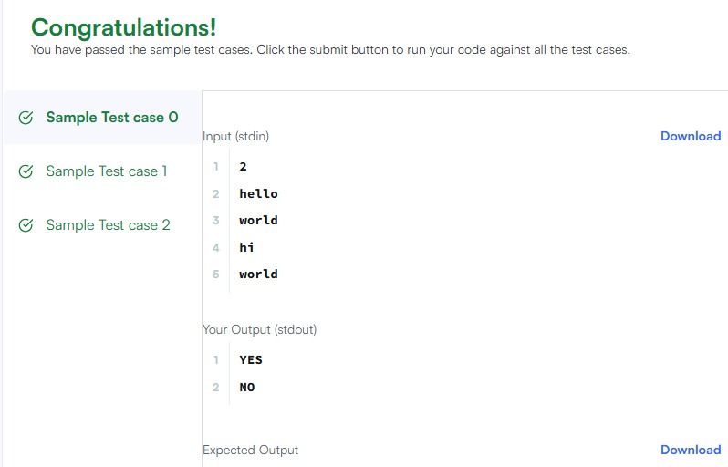
Task4:https://leetcode.com/problems/rotate-string/
class Solution {
public boolean rotateString(String s, String goal) {
if (s.length() != goal.length()) {
return false;
}

return (s + s).contains(goal);
}
}
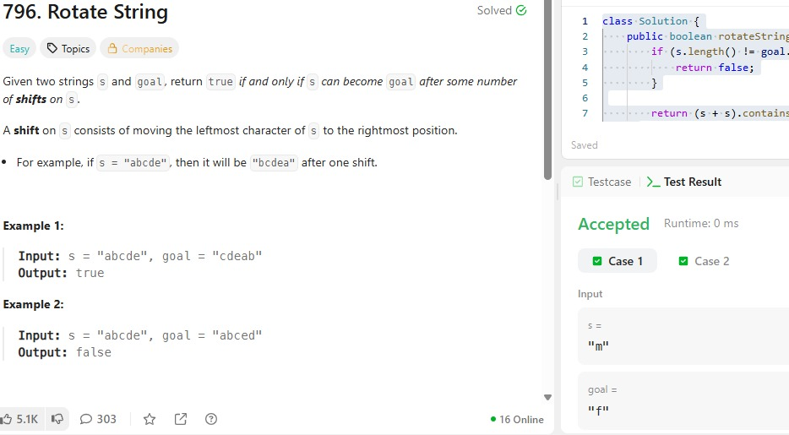
SESSION 3
Task 5:https://www.hackerrank.com/challenges/mars-exploration/
import java.util.*;

public class Solution {

public static int marsExploration(String s) {
String expected = "SOS";
int count = 0;

for (int i = 0; i < s.length(); i++) {
if (s.charAt(i) != expected.charAt(i % 3)) {
count++;
}
}

return count;
}

public static void main(String[] args) {
Scanner sc = new Scanner(System.in);

String s = sc.nextLine();

System.out.println(marsExploration(s));

sc.close();
}
}
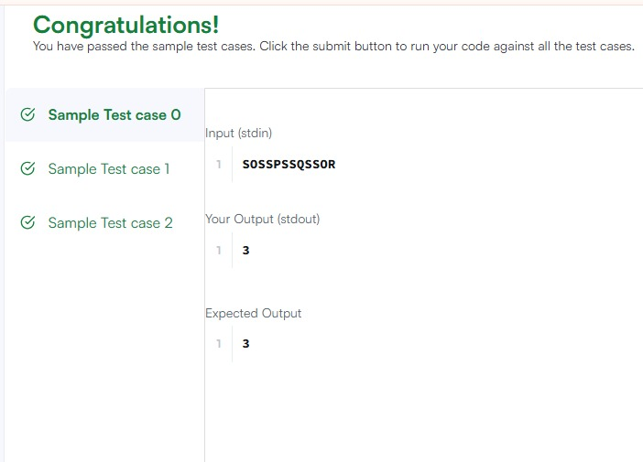
Task6:https://leetcode.com/problems/find-all-anagrams-in-a-string/
import java.util.*;

class Solution {
public List<Integer> findAnagrams(String s, String p) {
List<Integer> result = new ArrayList<>();

if (s.length() < p.length()) {
return result;
}

int[] count = new int[26];

// Count characters in p
for (char c : p.toCharArray()) {
count[c - 'a']++;
}

int left = 0;
int right = 0;
int required = p.length();

while (right < s.length()) {
char c = s.charAt(right);

// If this character is needed
if (count[c - 'a'] > 0) {
required--;
}

count[c - 'a']--;
right++;

// Keep window size equal to p.length()
if (right - left > p.length()) {
char leftChar = s.charAt(left);

count[leftChar - 'a']++;

if (count[leftChar - 'a'] > 0) {
required++;
}

left++;
}

// All required characters are present
if (required == 0) {
result.add(left);
}
}

return result;
}
}
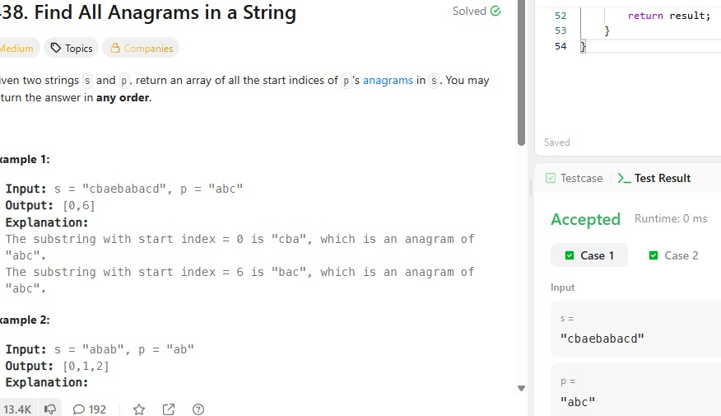
SESSION 4
Task7:https://www.hackerrank.com/challenges/palindrome-index/problem
import java.util.*;

public class Solution {

public static int palindromeIndex(String s) {
int left = 0;
int right = s.length() - 1;

// Find the first mismatch
while (left < right) {
if (s.charAt(left) != s.charAt(right)) {

// Try removing the left character
if (isPalindrome(s, left + 1, right)) {
return left;
}

// Try removing the right character
if (isPalindrome(s, left, right - 1)) {
return right;
}

return -1;
}

left++;
right--;
}

// Already a palindrome
return -1;
}

private static boolean isPalindrome(String s, int left, int right) {
while (left < right) {
if (s.charAt(left) != s.charAt(right)) {
return false;
}

left++;
right--;
}

return true;
}

public static void main(String[] args) {
Scanner sc = new Scanner(System.in);

int q = sc.nextInt();

while (q-- > 0) {
String s = sc.next();
System.out.println(palindromeIndex(s));
}

sc.close();
}
}
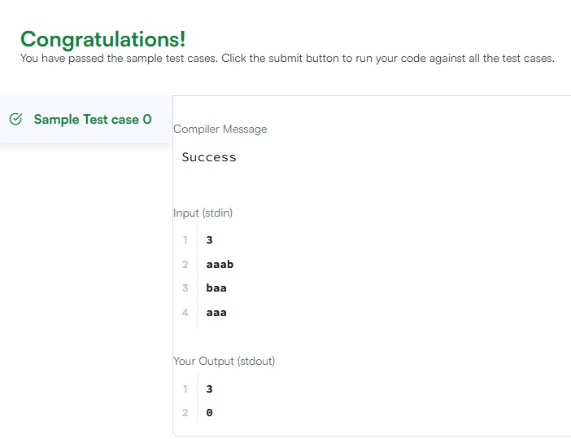
Task8:https://leetcode.com/problems/find-the-index-of-the-first-occurrence-in-a-string
class Solution {
public int strStr(String haystack, String needle) {
int n = haystack.length();
int m = needle.length();

// Check every possible starting position
for (int i = 0; i <= n - m; i++) {
int j = 0;

// Compare characters of needle with haystack
while (j < m && haystack.charAt(i + j) == needle.charAt(j)) {
j++;
}

// Entire needle matched
if (j == m) {
return i;
}
}

return -1;
}
}
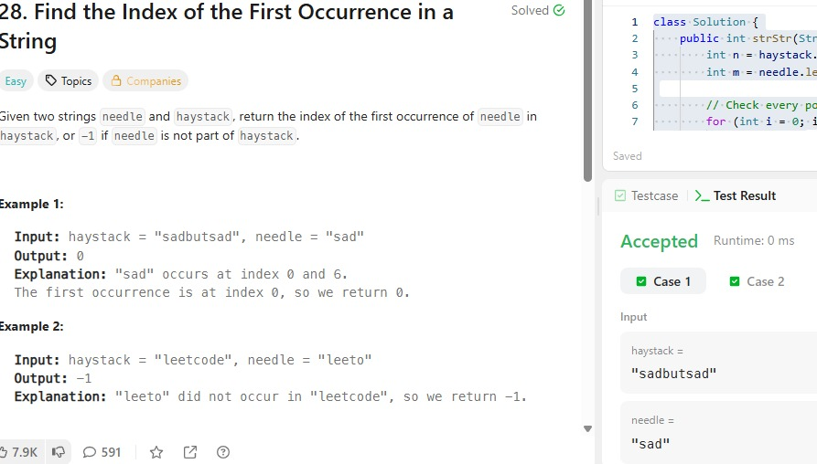

SESSION 5
Task 9:https://leetcode.com/problems/longest-palindromic-substring/
class Solution {

public String longestPalindrome(String s) {
if (s == null || s.length() < 2) {
return s;
}

int start = 0;
int end = 0;

for (int i = 0; i < s.length(); i++) {

// Odd length palindrome
int len1 = expandAroundCenter(s, i, i);

// Even length palindrome
int len2 = expandAroundCenter(s, i, i + 1);

int len = Math.max(len1, len2);

if (len > end - start + 1) {
start = i - (len - 1) / 2;
end = i + len / 2;
}
}

return s.substring(start, end + 1);
}

private int expandAroundCenter(String s, int left, int right) {

while (left >= 0 && right < s.length()
&& s.charAt(left) == s.charAt(right)) {

left--;
right++;
}

return right - left - 1;
}
}
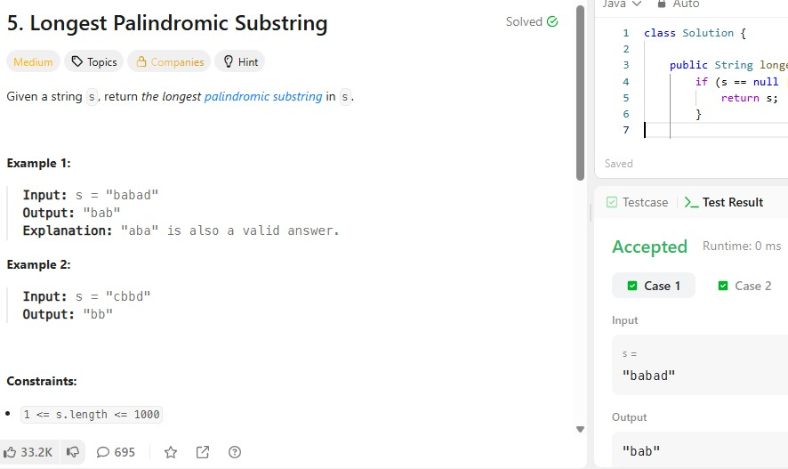
Task10:https://www.hackerrank.com/challenges/circular-palindromes/
import java.io.*;
import java.util.*;

public class Solution {

// Returns the length of the longest palindromic substring
private static int longestPalindrome(String s) {
int maxLen = 1;

for (int i = 0; i < s.length(); i++) {

// Odd length palindrome
maxLen = Math.max(maxLen, expand(s, i, i));

// Even length palindrome
maxLen = Math.max(maxLen, expand(s, i, i + 1));
}

return maxLen;
}

// Expand from the center
private static int expand(String s, int left, int right) {
while (left >= 0 && right < s.length()
&& s.charAt(left) == s.charAt(right)) {
left--;
right++;
}

return right - left - 1;
}

public static void main(String[] args) throws Exception {

BufferedReader br = new BufferedReader(
new InputStreamReader(System.in));

int n = Integer.parseInt(br.readLine().trim());
String s = br.readLine().trim();

for (int k = 0; k < n; k++) {

// Create rotation:
// s[k...n-1] + s[0...k-1]
String rotated = s.substring(k) + s.substring(0, k);

System.out.println(longestPalindrome(rotated));
}
}
}
